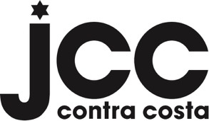

LIABILITY WAIVER

By registering for this pool event, I agree that the Contra Costa Jewish Community Center and its directors, employees, agents, and volunteers will not be liable for any personal injury, disability, damage, or disease incurred by myself, my family members, or guests, including minors, during or as a result of this activity. I understand that I will be solely responsible for any personal injury, disability, damage, or disease sustained by participation. In addition, I, along with others in my group, will maintain social distancing during the activities and follow all protocols established by the Contra Costa County Department of Public Health.

